Parametric Design:

|  |  |  |
| --- | --- | --- |
| **Components** | **Dimensions** | |
| Digital Meter | 172X180.5X76(in mm) | |
| Screws |  | |
| GSM Module |  | |
| Max232 IC |  | |
| Li-ion Battery |  | |
| 16X2 LCD Display |  | |
| Capacitors |  | |
| Resistors |  |  |
|  |  | |
|  |  | |
|  |  | |

**Configuration Design:**

* Load is connected to meter
* Meter will be connected to GSM module
* GSM is connected to the micro controller.
* Micro controller takes the data from the meter, sends it to the GSM modem and to the display.
* GSM module sends the data to users’ mobile and electricity board.
* Meter is placed in a box; a proximity sensor is attached to the door of the box for tamper detection.

There are three basic units

1. Metering unit

2. Meter interfacing unit

3. Communication unit

METERING UNIT:

Generally electricity transmission will be done through transformers by a power companies. From transformer connection is given to meter and then load is connected to it.

Basically in this unit, it consists of instrument used for measuring power usage. It displays the readings of power usage based on load of the electronic devices connected to the meter.

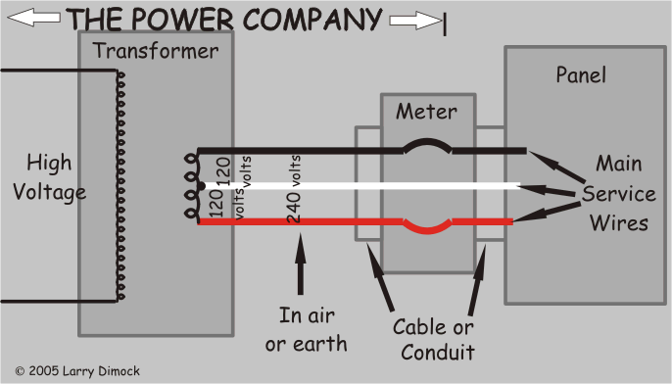

From the meter the reading will be sent to the meter interfacing unit, it analyses the data and transfers it to the communication module.

**Meter Interfacing Unit(MIU):**

This unit is connected to the meter from which the data is received. It consists of a micro controller which can analyze the data received from the meter and send it to GSM module.

Max232 IC will be used for converting signals from the micro controller

**Max232 IC:**

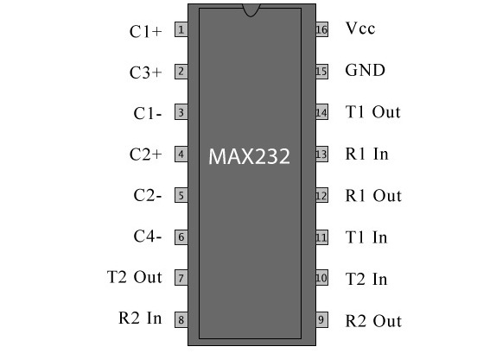

* The MAX232 is an IC,that converts signals from an RS-232 serial port to signals suitable for use in TTL compatible digital logic circuits.
* The MAX232 is a dual driver/receiver and typically converts the RX, TX, CTS and RTS signals.

**Communication Unit:**

It consists of GSM module. GSM technology is a commonly used tech